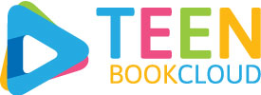

Dear Tumbler:

TeenBookCloud is a curated database of e-books and other digital content for Middle Schools and High Schools, as well as Public Libraries.
The growing collection features over 1000 titles, including student-favorite Graphic Novels, enhanced e-books with full audio narration and highlighted text, classic literature, national geographic videos, and more!
The site supports a wide range of readers’ interests and levels. We’ve partnered with Orca Books and Saddleback books to bring you hundreds of High-Interest/Low-Level content. In addition, our new AP English section makes hundreds of curriculum books available to readers at the click of a button!
The quickest and easiest way to access your TBC collection is to click the link below:

http://www.teenbookcloud.com/autologin.aspx?U=midvale&P=login

